Verification Code: {{ verification_code }}
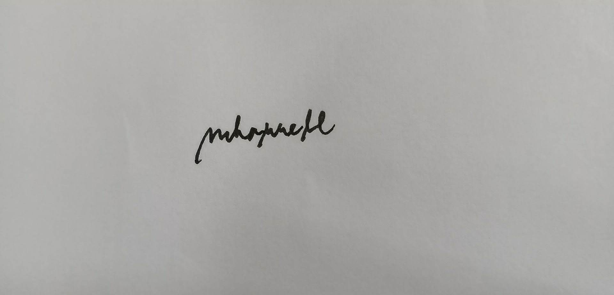
Verification Code: {{ verification_code }}
{{ purpose }}
{{ date_today }}
{{ date_day }}
5
{{ resident_age }}
{{ resident_name }}
{{ purpose }}
{{ date_today }}
{{ date_day }}
5
{{ resident_age }}
{{ resident_name }}

